And so the leaky ship sinks slowly, slowly
By Song Yingge | August 17, 2016, Wednesday |
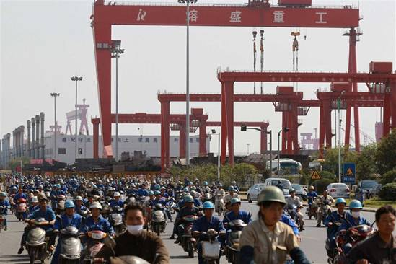
Back in better times, workers at the Rongsheng Heavy Industries shipyard in Nantong rose scooters and bicycles to work, as shown in this 2012 file photo. In its heyday, Rongsheng employed more than 30,000 workers, but only 100 are left on the payroll today. — IC
CHINA shipyards, faced with slumping world trade, overcapacity, cancelled orders and heavy losses, should by classic business practices be in bankruptcy. But that has been a slow, painstaking process.
Last week, shipping giant Wuhan Guoyu Logistic Group admitted it had failed to repay a 400 million yuan (US$60.3 million) bond on the due date. The Chinese media described the failure with the word “again!”
The group’s woes are just part of an industry mosaic, where the efforts of local governments and creditors to keep a leaking ship afloat aren’t working.
In July, Chen Zhaodong, director of Nantong’s Finance Bureau, committed suicide in woodland abutting Jiangsu Rongsheng Heavy Industries Group Co, once China’s largest shipyard.
The death, according to authorities, was tied to the shutdown of Rongsheng, a company Chen had endeavored to support as a pivotal player in Rugao, the town where Rongsheng is located. His ambition had been to create a modern port and bustling commercial center by 2020.
When Rongsheng halted operations earlier this year, burdened by debt of 22.6 billion yuan, Chen’s dream crashed.
Zhang Zhirong, chairman and founder of Rongsheng, had been trying to come up with financing to pay back creditors. In March 8, the group announced a debt-to-equity swap to offset up to 17.1 billion yuan in debt. The deal was designed to enable 22 creditor banks and 1,000 unpaid suppliers to profit from its shares.
Before that, Rongsheng had tried to transform itself into an energy company by acquiring an oil and gas company. The group renamed itself Huarong Energy and listed in Hong Kong.
The price of the shares jumped by 1.5 times from the first day of the debt-to-equity swap to 0.475 yuan last Friday, but the value has plummeted 122 percent since the company was renamed.
Yet, despite all the dire news, Rongsheng has never declared bankruptcy.
“Investors won’t allow it,” said Albert Cheng, a financial analyst at a cargo shipping agent. “They’ve been dragged too deeply into the debt of Rongsheng to let it collapse easily.”
Rongsheng’s woes first emerged in 2012, when Zhang reportedly was funneling huge sums of money to a partner in Japan in exchange for ship orders.
When Rongsheng’s capital base began cracking in 2014, the local government where the shipyard is located dismissed the problems as a short-lived difficulty tied to the downturn in global shipping and directed local banks to provide financing.
The Bank of China, a major “sponsor” at that time, had 6.3 billion yuan invested in the group when the debt-to-equity swap was inked. After the swap, the bank became Huarong’s largest shareholder.
The 14 banks knew the escalating risk they were taking pumping capital into the group, Cheng said, but soon they were in too deeply to clamor for bankruptcy.
“Without actual revenue, the capital provided by one bank just paid off the debt of another, and so the vicious cycle went on,” Cheng said. “No one wanted to stop until one day the chain broke at one hapless participating bank.”
For shipbuilders, forestalling bankruptcy has not been the hoped-for salvation.
Wuhan Guoyu’s major subsidiary, Yangzhou Guoyu Shipbuilding Co, had to cease operations last year. This January, more than 200 of its employees blocked the streets around its site in the city of Yangzhou in Jiangsu province, in a protest over 30 million yuan in back wages owed to 1,000 workers.
Sinking deeper if not bankrupt
Wuhan Guoyu, like Rongsheng, started relying on loans to keep itself afloat as revenue fell. By the end of March last year, 87 percent of debt totaling 768 million yuan was due to be paid within a year.
At the end of last year, Singapore-based Pioneer Marine, cancelled three of eight orders it had placed with the yard.
Tim Wang, manager of a ship-equipment company that once supplied Yangzhou Guoyu, said it would be sensible to shut down the yard before more losses mount up. But the shipyard, like Rongsheng, hasn’t declared bankruptcy.
Along the coastline of Jiangsu province, Wang now sees rusty steel sheets and built ships idling in drydock. Every ship’s berthing costs hundreds and thousands yuan a day in rent and maintenance, fully paid by the shipyards themselves.
Such expenditures in the past were paid by ship owners, but now with ocean shipping in the doldrums, owners are declining or canceling the delivery of vessels. Finding new buyers is problematical.
“The shipbuilding industry is in a financial crisis and shutting them down is the only solution left,” Wang said.
But bankruptcy laws in China don’t make that process easy.
Yuan Yuan, deputy director of Chan Capital Law Firm, told Shanghai Daily that companies unable to survive on their own cannot be approved for bankruptcy if they are bound to others backing them up with solvency.
“Creditors have the right to ask loan guarantors to pay up,” Yuan said. “The court can declare insolvency only if they don’t pay up.”
In shipping industry, parent companies usually provide letters of guarantee to support bank loans to subsidiaries.
“In too many cases, small shipyards that should stop operations don’t,” said Xue Yingchun, founder of a shipping agent and a former ship’s captain. “They finally drag their guarantors down with them.”
Governments have been aware of problems in the shipbuilding industry for some time, but a sense of “too big to fail” and the illusion of a world crisis that is temporary has caused authorities to hold off on workable bankruptcy policies.
Closing shipyards for good means the permanent loss of thousands of jobs – a likelihood that local governments are loath to entertain.
But hopes for an industry turnaround have sunk so deeply into the sector’s debt that government and banks may be forced to swallow a bitter pill.
Rongsheng, which once employed 30,000 workers, now has now less than 100 left on the payroll.
Despite halted operations at some shipyards, China still had an annual capacity of 80 million tons of carrying weight in shipbuilding last year. The China Association of the National Shipbuilding Industry said that is “enough to satisfy global needs.”

